Year 8 |  | Percentages and Financial Maths | Non Calculator  Section
- Connect fractions, decimals and percentages and carry out simple conversions (ACMNA157)  - Find percentages of quantities and express one quantity as a percentage of another, with and without digital technologies (ACMNA158)  - Solve problems involving the use of percentages, including percentage increases and decreases, with and without digital technologies (ACMNA187)  - Investigate and calculate Goods and Services Tax (GST), with and without digital technologies  - Investigate and calculate ‘best buys’, with and without digital technologies (ACMNA174)  - Solve problems involving profit and loss, with and without digital technologies (ACMNA189) |  |  | Name___________________
Answer all questions in the spaces provided on this test paper by:
Writing the answer in the box provided.
or
Shading in the bubble for the correct answer from the four choices provided.
Show any working out on the test paper. Calculators are not allowed.
Which diagram has 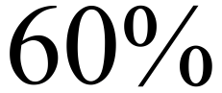 shaded?
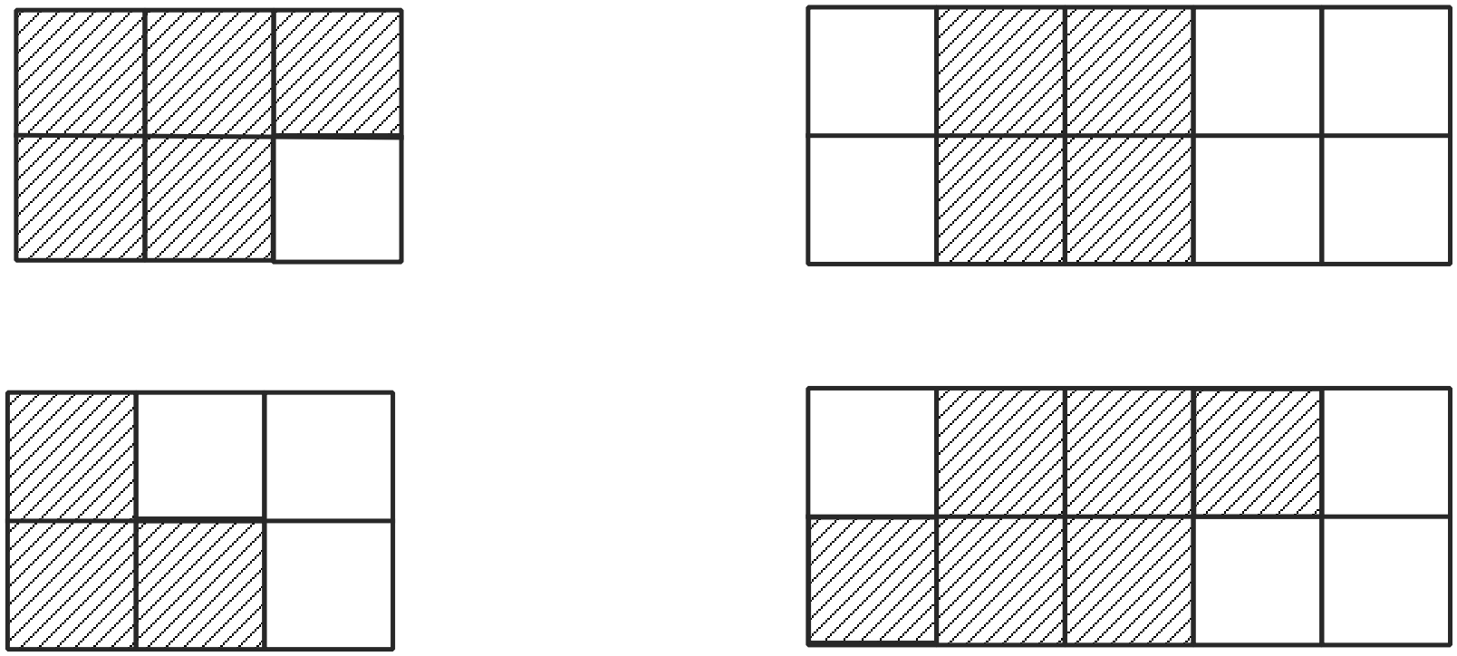

 | Write 40% as a fraction in simplest form.
 | Write 46% as a decimal number.
Convert the fraction 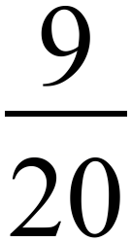 to a percentage.
%

What is 35% of 600?

70 140 210 280

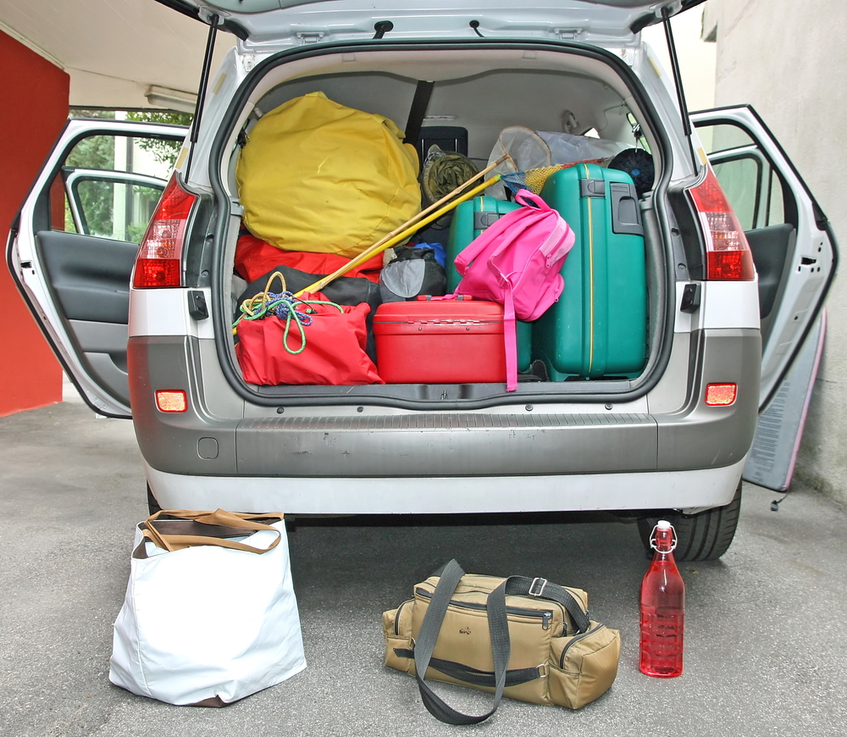
A loaded car has a mass of 1600 kg. Its load makes up 30% of this mass.
What is the mass of the load?

Martin is asked to calculate 75% of $240.
Which is the correct result?

$60 $120 $150 $180

Ronnie gets 36 correct answers out of 40 on a competency test.
What percentage of the answers did she get correct?

Which fraction is equivalent to 64%?

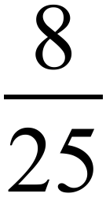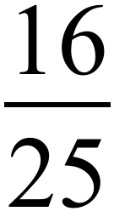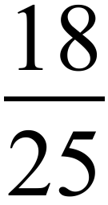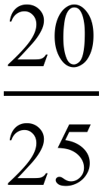

 | What percentage is the same as 0.875?
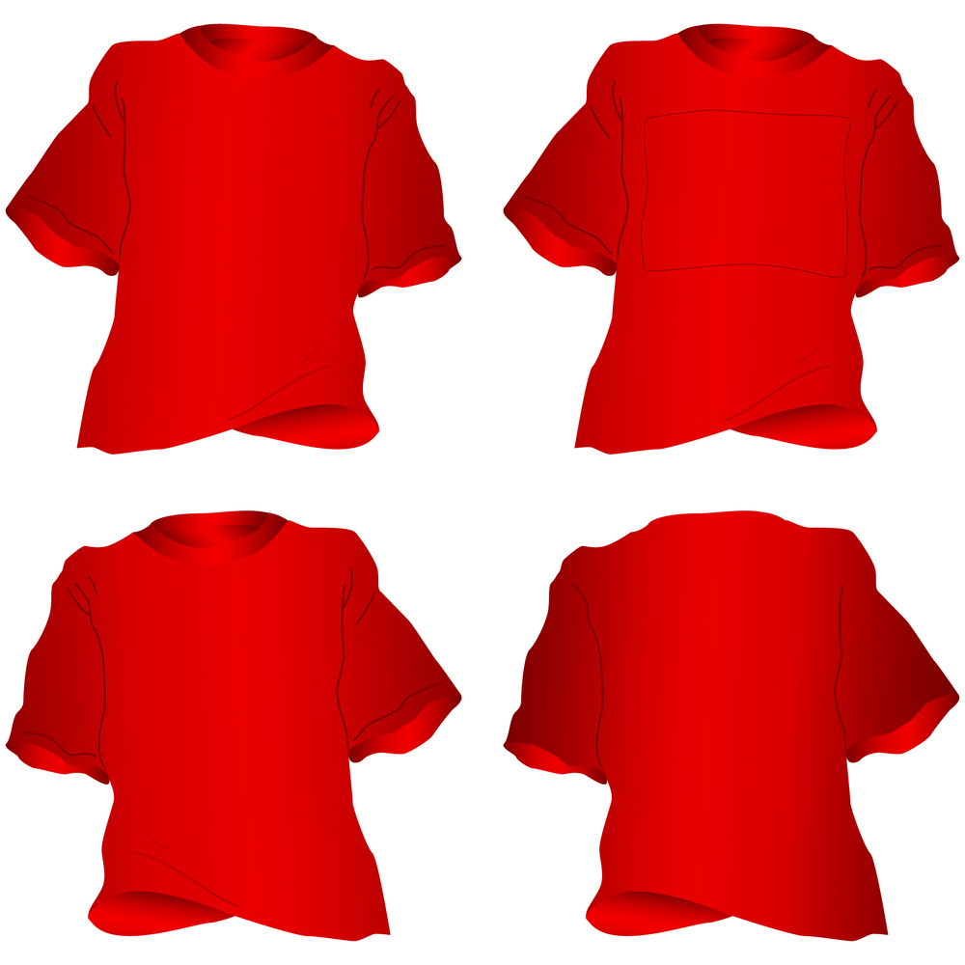
Matthew only owns T shirts in three colours; red, black and yellow. He counts his T shirts and finds that 40% are black and 15% are yellow. What percentage of the T shirts are red?

15% 35%

45% 55%

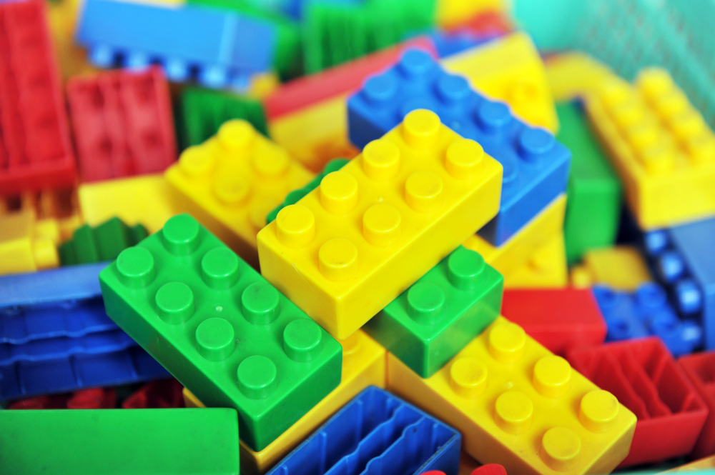
In January this year Marcus had 800 pieces of Lego. After his birthday in May, he now has 1000 pieces of Lego. What is the percentage increase since January?

A beauty salon bought bottles of moisturiser for $30 each and sold them at a 60% profit.
What was the selling price of a bottle of moisturiser?

$18 $48 $60 $90

An auto-parts store sells touch-up paint for $8.00 before GST.
What is the price when 10% GST is included?

The price of a model car is $132 including GST.
What was the price before adding the GST?

$100 $120 $130 $150

Cedric buys a TV for $500 and sells it later for $320.
What was his loss as a percentage of the cost price?

Which is the better buy, 200 ml of shampoo for $6.40 or 300 ml for $9.90? Explain why.

……………………………………………………………………..

……………………………………………………………………..

……………………………………………………………………..

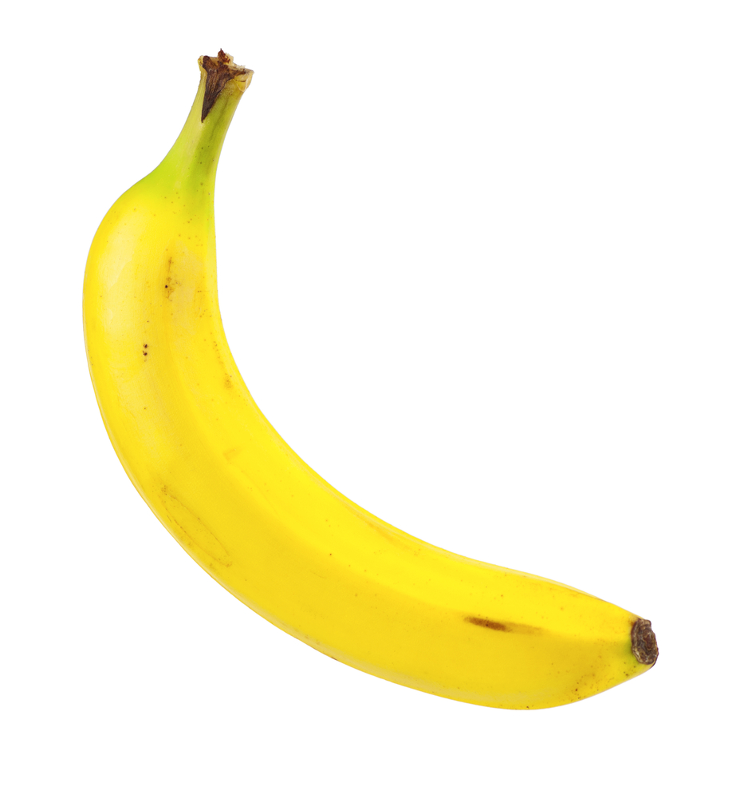
In a delivery of bananas to a grocery store, 5% are found to be spoiled.
If 15 were spoiled, how many were good?

Year 8 |  | Percentages and Financial Maths | Calculator Allowed  Short Answer  Section
 |  |  | Name___________________
Answer all questions in the spaces provided on this test paper by:
Writing the answer in the box provided.
or
Shading in the bubble for the correct answer from the four choices provided.
Show any working out on the test paper. Calculators are allowed.
 | 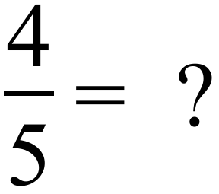
Jodie finds that  of her class like playing Minecraft. What percentage does this represent?

%

 | What is 5.5% when written as a decimal?
Sylvie has a library of books in her home.
There are 120 non-fiction books and 480 fiction books.
What percentage of the library is fiction?

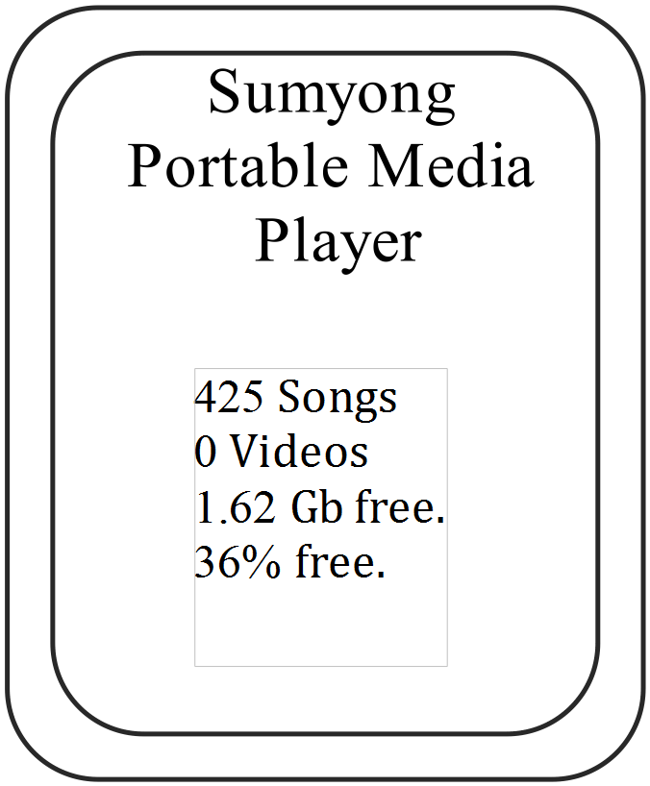Mason transfers some songs onto his portable media player. After he has finished he sees the message shown. What percentage of the storage on the player has he used?

14% 24%

64% 74%
What is 35.5% of $ 6 400?

$ .
 | 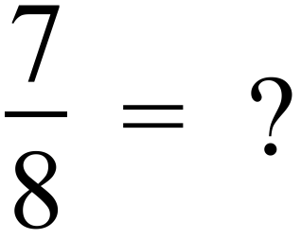
Keelan is saving 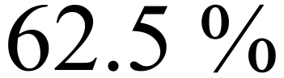 of his weekly pocket money to buy a bike.
If his weekly pocket money totals $36.00, how much does he save?

$22.50 $25.00 $27.00 $30.50
Keith is the goal kicker for the Tigers Rugby League team. He had 85 shots at goal last season and was successful with 74 of them.
What percentage of his shots were successful (to the nearest whole number)?

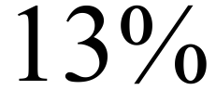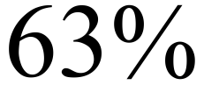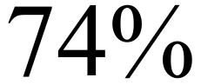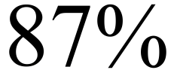
Last financial year a company had expenses of $ 250 000 and income of $350 000.
What percentage profit did the company make on its expenses?

%

Decrease $2 480.00 by 18%.

$

When he had his hours reduced in his part time job, Hank’s pay went down from $58 per week to $45 per week.

What is the percentage decrease in his pay? (Answer to the nearest whole number.)

13% 22% 33% 77%
A retailer has priced a printer at $125.95 including 10% GST.
Find the price before GST was added (Answer to the nearest 5 cents)

$

Tegan was shopping for a new school bag and saw that the bag she wanted, which was normally priced at $36.00, was discounted by 20%. She had her mother’s frequent customer card which entitled her to a further 5% discount. What did she pay for the bag? (Answer to the nearest 5 cents.)

$

Write the following in order from smallest to largest.

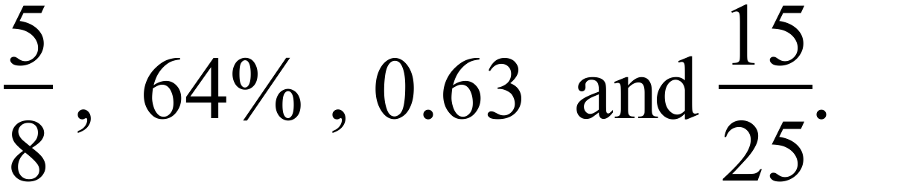

Year  8 |  | Percentages and  Financial Maths | Calculator Allowed  Connected Answer  Section
 |  |  | Name___________________
Write all working and answers in the spaces provided on this test paper.
 |  |  |  | Marks
 | There are four ways that you can buy Loner brand soft drink in a supermarket.  Which is the best value for money? ( Explain how you determined your answer.)  A pack of six 300 ml cans for $7.20. Individual 375 ml cans for $2.80 each.  Individual 1.25 litre bottles for $4.80 each. Individual 2 litre bottles for $7.80.  ……………………………………………………………………………………..  ……………………………………………………………………………………..  …………………………………………………………………………………….. |  |  | 3
Hugh is about to copy data from his computers C drive onto an external hard drive,
The C drive has 85% of its available space used and the external drive has 24% of its space used.

 | - The C drive has a capacity of 820 GB. How many GB of data does it currently store?  ……………………………………………………………………………………..  …………………………………………………………………………………….. |  |  | 1
 | - The external drive has a total capacity of 4 100 GB. How many GB of data can be added to it before it is full?  ……………………………………………………………………………………..  …………………………………………………………………………………….. |  |  | 1
 | - What percentage of the external drive will still be free after Hugh has backed up all of his C drive?  ……………………………………………………………………………………..  …………………………………………………………………………………….. |  |  | 1

Percentages and Financial Maths
ANSWERS
Non Calculator Section ( 1 mark each)

Q no |  | Answer
 | 6 out of 10 is 60%, the last diagram | (4th Answer)
 | 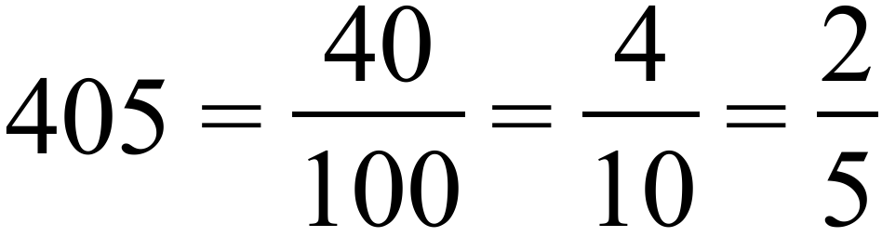
 | 46% =0.46
 | 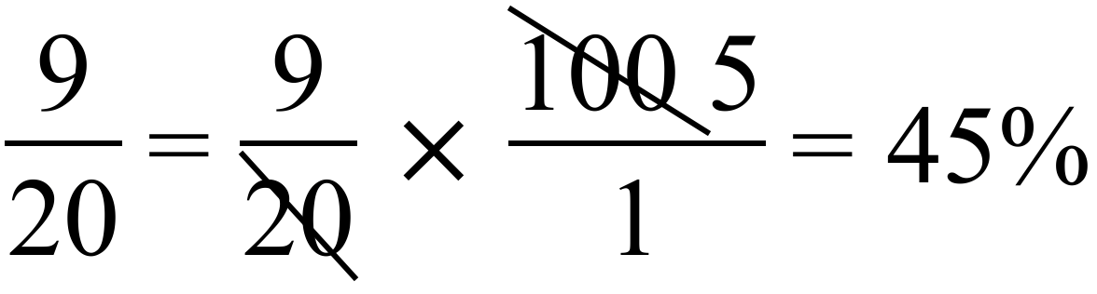
 | 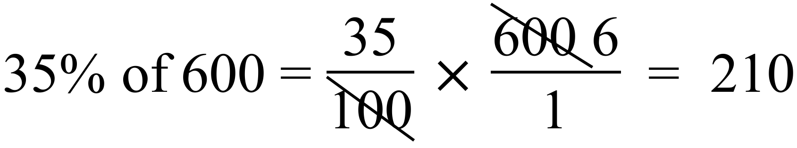 | (3rd Answer)
 | 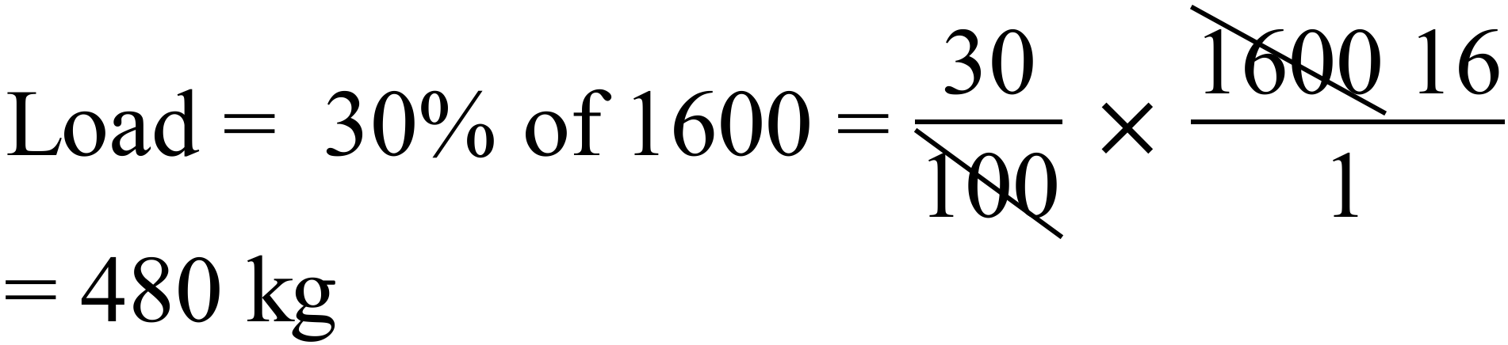
 | 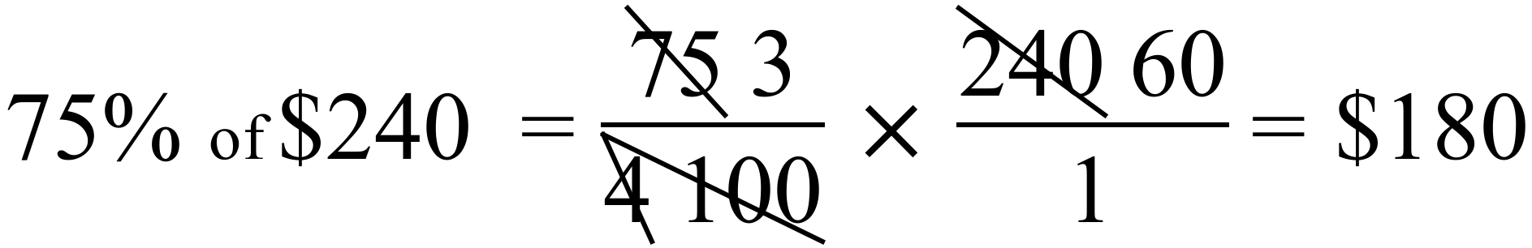 | (4th Answer)
 | 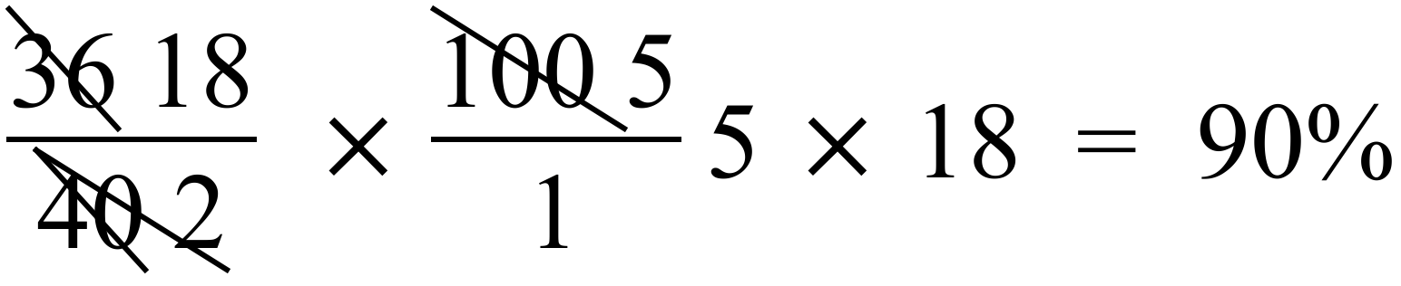
 | 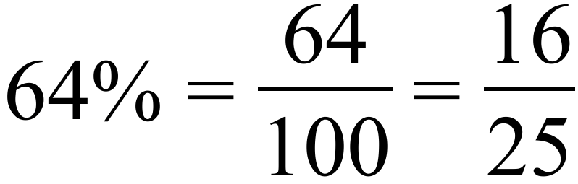 | (2nd Answer)
 | Black and yellow T shirts make up 55% of total.  This leaves 45% which are red. | (3rd Answer)
Increase = 200 pieces
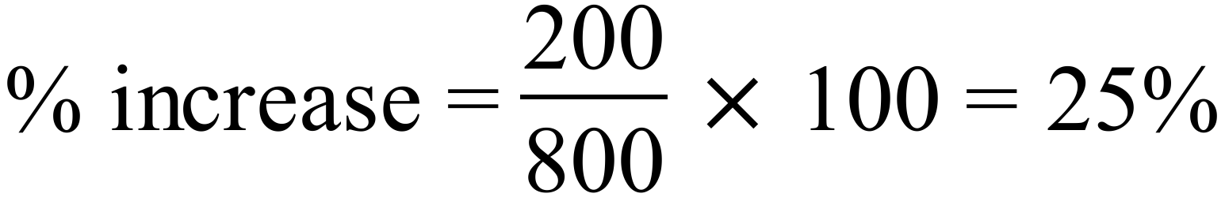
 | 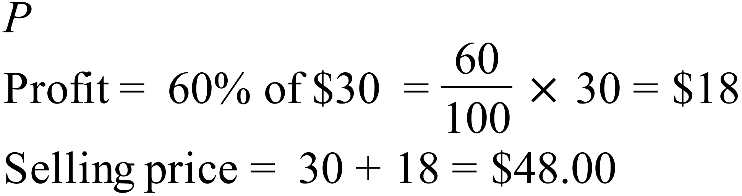 | (2nd Answer)
 | 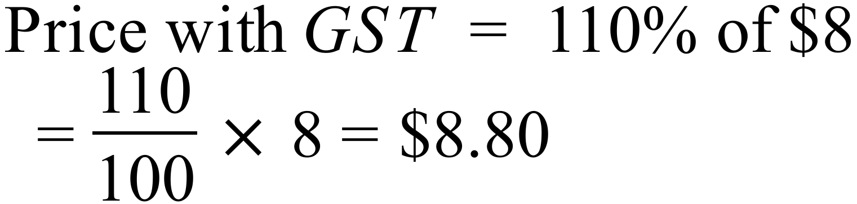
 | 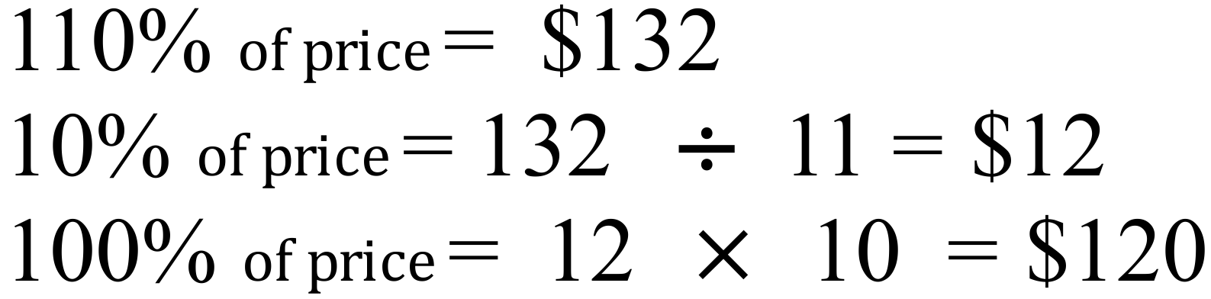 | (2nd Answer)
 | 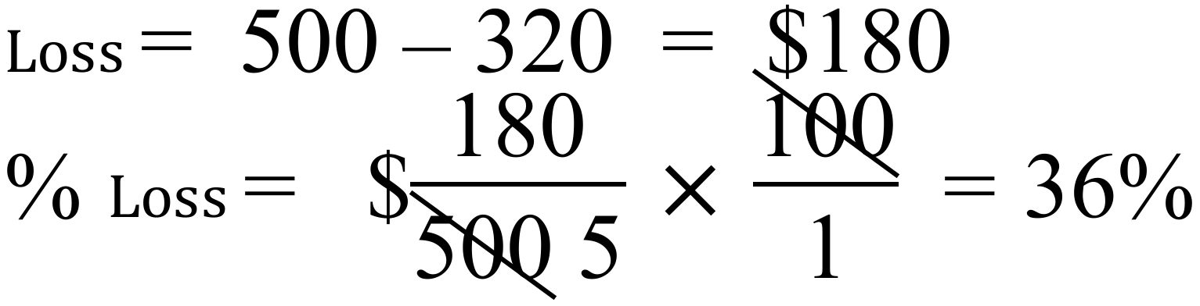
 | 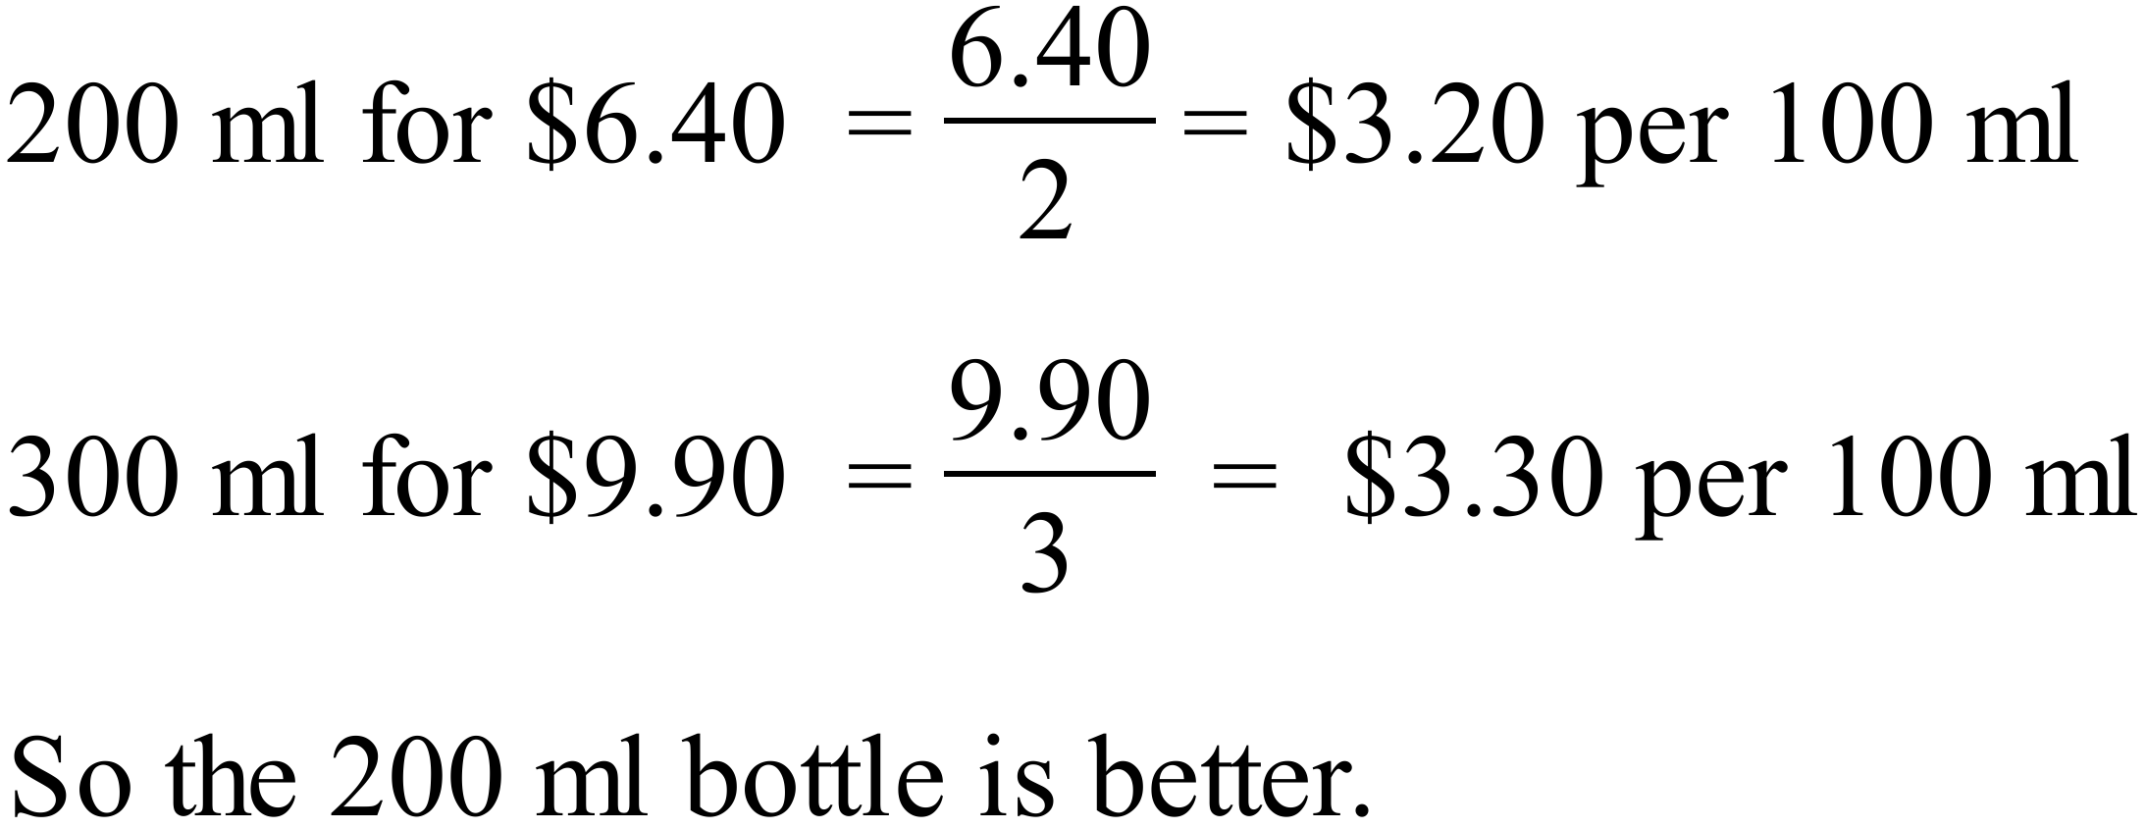
 | 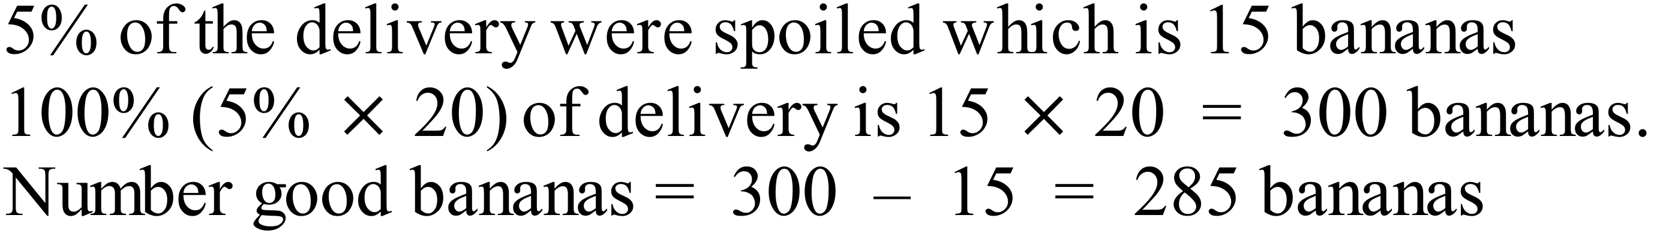

Calculator Allowed Short Answer Section ( 1 mark each)

Q no |  | Answer
 | 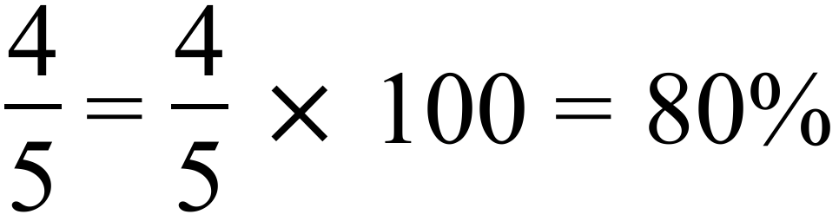 | (3rd Answer)
 | 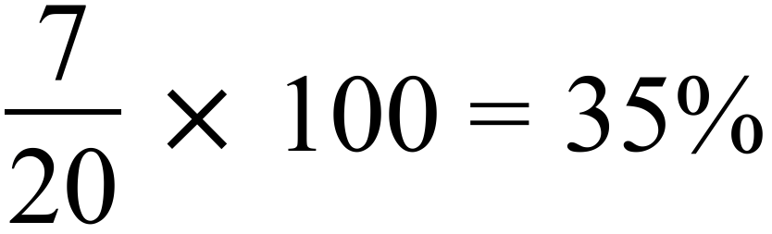
 | 5.5%=5.5 / 100 =0.055
 | 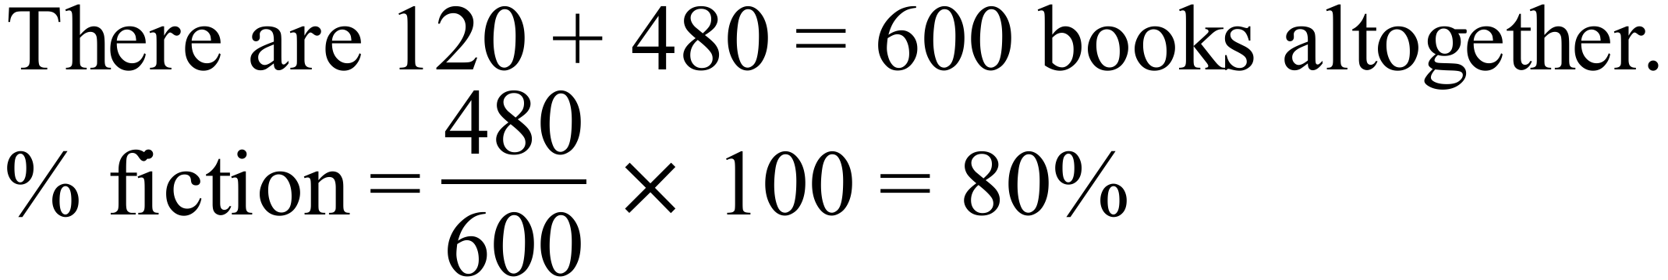
 |  | (3rd Answer)
 | 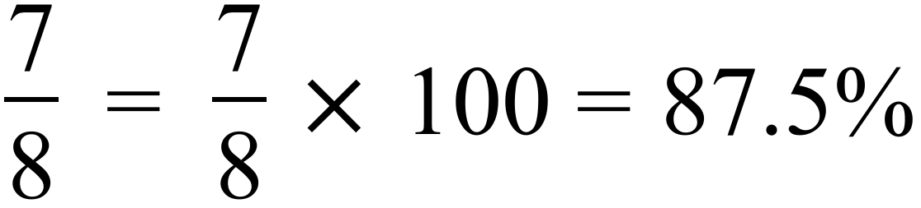 | (2nd Answer)
 | 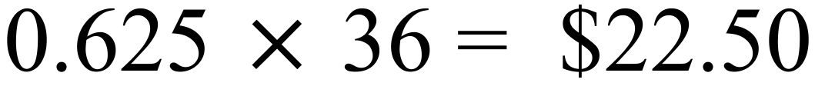 | (1st Answer)
 | 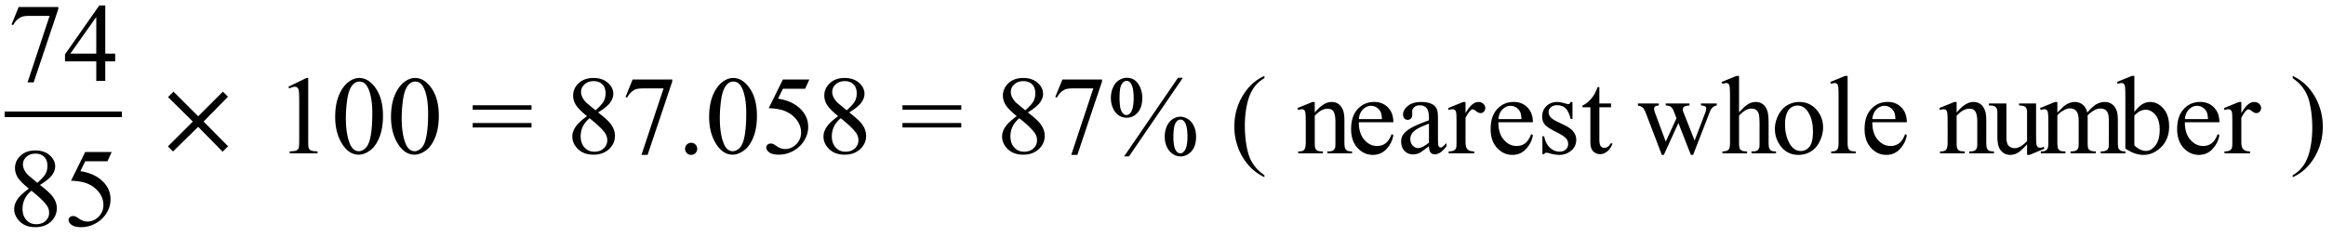 | (4th Answer)
 | 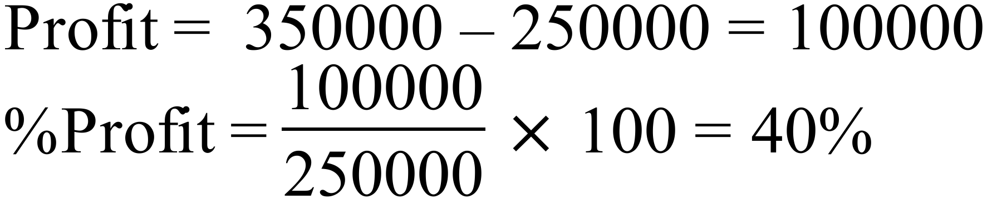
 | 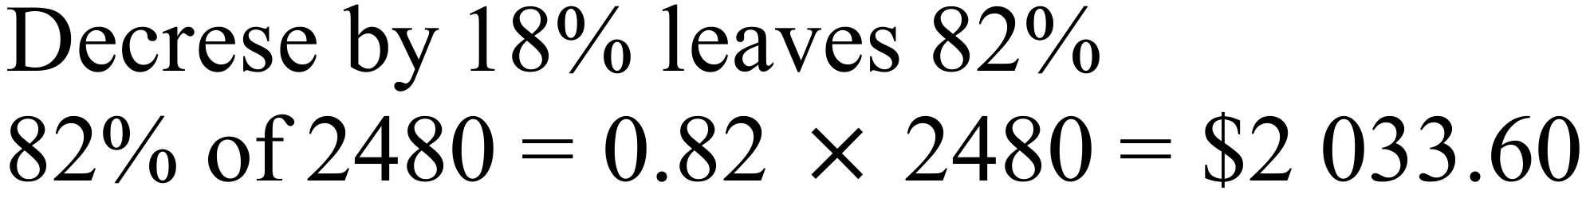
 | 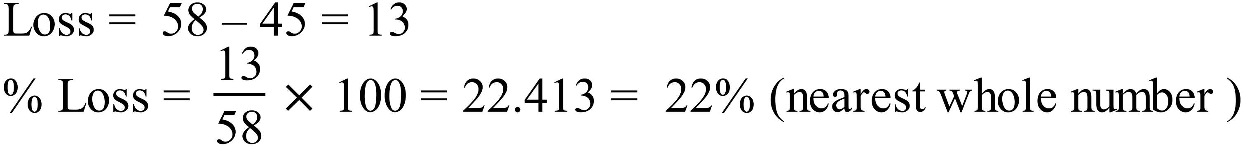 | (2nd Answer)
 | 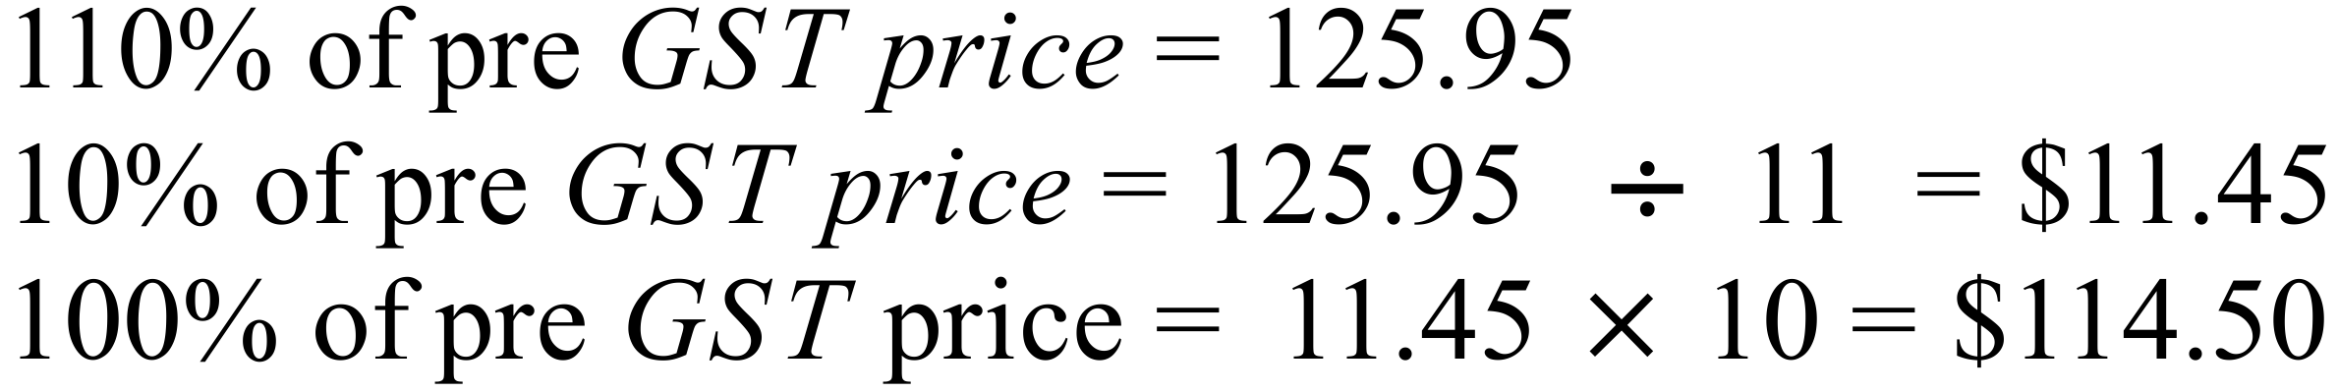
 | 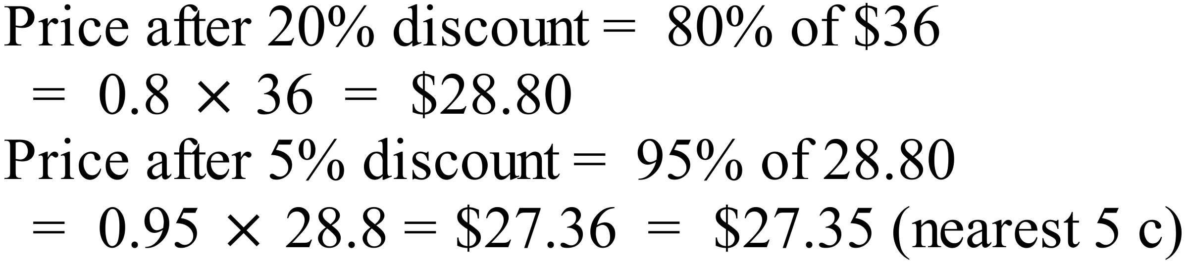
 | 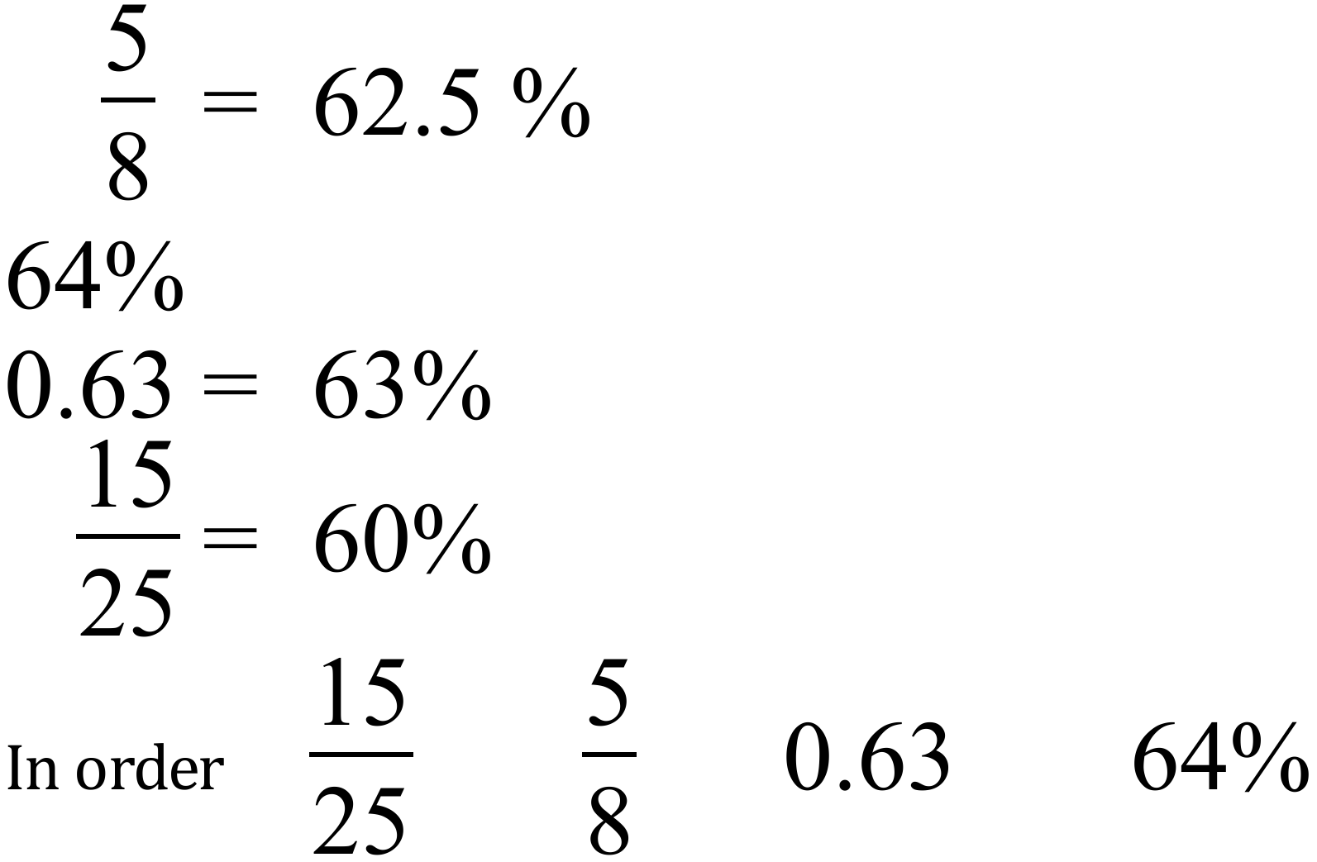

Answers
Connected Answer Section
1. | A pack of six 300 ml cans for $7.20.  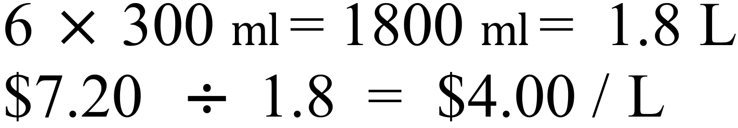  Individual 375 ml cans for $2.80 each.  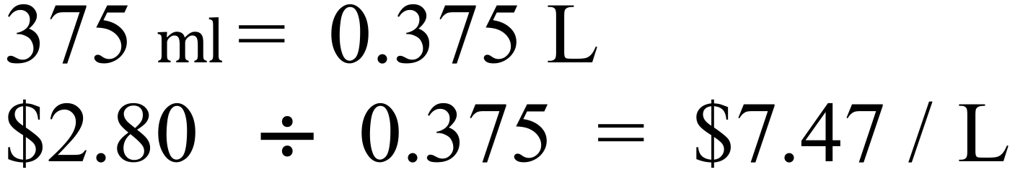  Individual 1.25 litre bottles for $4.80 each.  Individual 2 litre bottles for $7.80.  The 1.25 L bottles are the best buy. | 2 marks for calculations similar to those shown for a comparative rate.  1 mark for comparing and giving correct answer.
2 |  | 1
 | 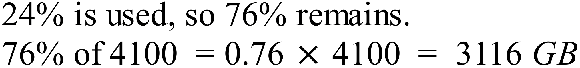 | 1
 | - 3116 available before backup, of 697 GB  Amount available after = 3116 – 697=2419  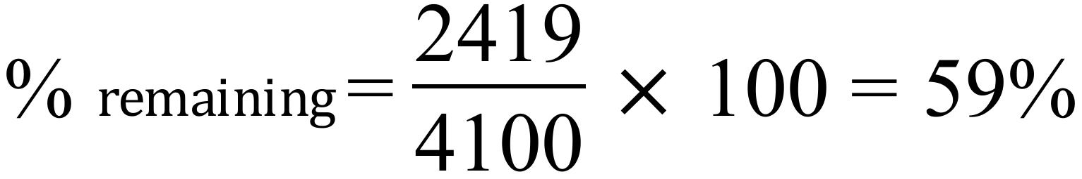 | 1

